University Information Web

|  |  |  |
| --- | --- | --- |
| **Ehtisham Malik**  **051-23-138392** | **Umair Ahmed Khan**  **051-23-138195** |  |



Supervised by

**Dr. Syed Irfan Sohail**

A Final Year Project Proposal Report is

Submitted in Partial Fulfilment of the

Requirements for the Degree of

Bachelor of Science in Computer Science

**Department of Computing & Technology**

**Iqra University**

**2025**

# Declaration

We hereby affirm that this work, in its entirety or in part, is entirely original and has not been plagiarized from any external source. We declare that this report has been meticulously prepared solely based on our individual efforts under the sincere and invaluable guidance of our esteemed teachers, especially Dr. Syed Irfan Sohail. His unwavering support and mentorship have been instrumental in shaping the quality and depth of this endeavor. We take full responsibility for the authenticity and originality of the content presented in this report. If, by any chance, any part of this work is found to be copied from any source or reproduces the work of others, we are prepared to accept the consequences as per the institutional regulations and ethical standards. This report has not been previously submitted in support of any application for any other degree or qualification, whether at this or any other university or institute of learning. We express our heartfelt appreciation to Dr. Syed Irfan Sohail for his exceptional guidance and support throughout this academic pursuit. It is with great pride that we present this work, reflecting our commitment to academic integrity and the pursuit of knowledge.

**Ehtisham Malik**

**Reg ID:** **051-23-138392**

**Umair Ahmed Khan**

**Reg ID:** **051-23-138195**

# Dedication

To the extraordinary visionaries and the unwavering supporters who have propelled this project forward, we extend our heartfelt dedication. With deep appreciation to our esteemed mentors, cherished families, steadfast friends, and the exceptional contributions of every team member, we proudly present this endeavor to the world. May it serve as a beacon, igniting inspiration and fostering a brighter future driven by innovation and compassion, leaving a profound and lasting impact on the lives it touches. Together, we wholeheartedly embrace the boundless potential of human ingenuity, united in our mission to shape a better world for generations to come.

# Acknowledgements

We extend our heartfelt gratitude to our parents, grandmother, and especially Dr. Syed Irfan Sohail, for their unwavering support, both mentally and financially, throughout our journey. Without their constant encouragement and assistance, we would never have reached the position we are in today. Dr. Syed Irfan Sohail as our final-year project supervisor, played a pivotal role in guiding us and providing invaluable insights during these crucial times. He dedicated himself to working with us diligently over the past year, leading us on the right path to success and enlightenment whenever we sought his guidance. We also want to express our sincere appreciation to all the staff members of the department, whose contributions and teachings have been instrumental in shaping our knowledge and helping us complete our project. Their guidance and expertise have been pivotal to our growth and achievements. We would also like to extend our gratitude to the extended staff of the examination office, administration, and student office for their tireless efforts in supporting us throughout this journey. Once again, thank you to our parents, grandmother, Dr. Syed Irfan Sohail, and all the faculty and staff members involved, for being our pillars of strength and believing in our potential. Your unwavering support has made all the difference in our accomplishments. We are truly grateful for everything you have done for us.

# Abstract

The **University Information Web** is a centralized web-based platform developed to simplify and enhance the process of accessing reliable and comprehensive information about universities. This project addresses the common challenges faced by students, parents, and educational counselors when navigating scattered and inconsistent data across multiple sources. By aggregating critical information—such as admission criteria, academic programs, campus facilities, and student life—into a single, user-friendly interface, the platform enables users to make informed and confident educational decisions with ease. The system provides standardized, up-to-date university profiles, minimizing the time and effort required to compare institutions and reducing dependency on disparate or unofficial resources. Through its intuitive design and functionality, the University Information Web serves as a valuable decision-support tool for prospective students and their families. This project was developed under the supervision of **Dr. Syed Irfan Sohail**, whose insightful guidance, technical expertise, and continuous encouragement were instrumental in every stage of the project. His unwavering support and constructive feedback not only shaped the direction of the system but also inspired us to aim for excellence throughout the development process. We are deeply grateful for his mentorship and the knowledge he generously shared with us.

**Table of Contents**

Declaration 1

Dedication 2

Acknowledgements 3

Abstract 4

Chapter 1: Introduction 2

1.1 Overall Description 2

1.1.1 Objectives 2

1.1.2 Problem Description 2

1.1.3 Methodology 2

1.1.4 Product Scope 3

1.1.5 Business Context 3

1.1.6 User Classes and Characteristics 3

1.1.7 Operating Environment 3

1.1.8 Assumptions and Dependencies 4

1.2 Functional Requirements 4

1.2.1 Generate a Poll 4

1.2.2 Vote on the Proposal 4

1.3 External Interface Requirements 4

1.3.1 User Interfaces 4

1.3.2 Hardware Interfaces 4

1.3.3 Software Interfaces 5

1.3.4 Communications Interfaces 5

1.4 System Features 5

1.4.1 System Feature 1: University Search and Filtering 5

1.4.2 System Feature 2: Comparison Tool 5

1.5 Nonfunctional Requirements 5

1.5.1 Performance Requirements 5

1.5.2 Safety Requirements 5

1.5.3 Security Requirements 6

1.5.4 Software Quality Attributes 6

1.6 Scenario 6

1.7 Report Structure 6

Chapter 2: Literature Review 8

2.1. Introduction 8

2.2. Related Works 8

2.2.1. Terminology 8

2.2.2 Categorization of Existing Techniques 9

2.2.3. Limitations 13

2.3. Proposed Improvements in Existing Works 13

2.4. Summary 14

Chapter 3: System Design 16

3.1. UML Design 16

3.1.1. Work Flow Diagram 16

3.1.2. Class Diagram 18

3.1.3. Sequence Diagram 19

3.1.4. Activity Diagram 20

3.2 Introduction 21

3.2.1. Purpose 21

3.2.2. System Overview 21

3.2.3. Design Map 21

3.2.4. Definitions and Acronyms 21

3.3. Design Considerations 22

3.3.1. Assumptions 22

3.3.2. Constraints 22

3.3.3. Design Methodology 22

3.3.4. Risks and Volatile Areas 22

3.3.5. Risk Mitigation 22

3.4. Architecture 23

3.4.1. Overview 23

3.4.2. Subsystem, Component 23

3.4.3. Strategy 23

3.5. Database Schema 23

3.5.1. Tables, Fields, and Relationships 23

3.5.2. Data Migration 24

3.6. High-Level Design 24

3.6.1. View / Model Element 24

3.7. Low-Level Design 25

3.7.1. Module 25

3.8. User Interface Design 26

3.8.1. Application Controls 26

3.8.2. Screenshots 27

3.9. Use Case Diagram 28

3.9.1. Actor and Use Cases 28

3.9.1.1 User 28

3.9.1.2 Login 28

3.9.1.3 View Academic Programs 28

3.9.1.4 Explore Campus Life 28

3.9.1.5 Access Admissions 28

3.9.1.6 Compare Universities 28

3.9.1.7 View University Profiles 28

3.9.1.8 Search Universities 28

3.10. Architecture Diagram 30

3.10.1. Web Browser 30

3.10.2 Web Server 30

3.10.3 Application Logic 30

3.10.4 University Cards 30

3.10.5 Sign-In Page 30

3.10.6 Database 30

3.11. Summary 32

Chapter 4: Implementation 34

4.1. Discussion 34

4.1.1. Problem-Solving Approach 34

4.1.2. User-Centric Design Philosophy 34

4.1.3. Scalability and Flexibility 34

4.2. Development Methodologies 34

4.2.1. Agile Development 34

4.2.2. User-Centered Design (UCD) 35

4.2.3. Data-Driven Decision-Making 35

4.3 Implementation Tools and Technologies 35

4.3.1. Programming Languages and Frameworks 35

4.3.2. Database Management 35

4.3.3. APIs and Integrations 35

4.3.4. Hosting and Deployment 35

4.3.5. Version Control 36

4.3.6. Testing Tools 36

4.4 Summary 36

Chapter 5: Testing 38

5.1 Testing Techniques Employed for This Project 38

5.2 Test Cases 39

5.3 Test Results 39

5.4 Summary 40

Chapter 6: Conclusion and Future Work 42

6.1 Conclusion 42

6.2 Future Work 42

6.2.1 Real-Time Data Integration 42

6.2.2 User Registration and Personalization 43

6.2.3 Global University Inclusion 43

6.2.4 Application Process Integration 43

6.2.5 Community Features: Reviews and Forums 43

6.2.6 AI-Based Recommendation Engine 44

6.2.7 Mobile Application Development 44

6.2.8 Administrative Dashboard for Universities 44

6.3 Final Thoughts 44

References: 45

**List of Figures:**

Figure 3. 1: Work Flow Diagram 17

Figure 3. 2: Class Diagram 18

Figure 3. 3: Sequence Diagram 19

Figure 3. 4: Activity Diagram 20

Figure 3. 5: High-Level Design 25

Figure 3. 6: Low-Level Design 26

Figure 3. 7: User Interface Design 27

Figure 3. 8: Use Case Diagram 29

Figure 3. 9: Architecture Diagram 31

**List of Tables:**

Table 5.1: Test Cases 39

**Chapter 1 Introduction**

# Chapter 1: Introduction

The University Information Web is a centralized platform designed to address the challenges associated with finding and comparing reliable information on universities. It functions as an extensive resource for students, parents, and educational advisors, streamlining the decision-making process by offering a wide range of essential data in one place. University Information Web allows users to explore university options based on key factors such as admissions requirements, campus life, academic programs, and more. In a world where accurate information is critical to making informed educational decisions, University Information Web eliminates the need to visit multiple websites, instead consolidating up-to-date, standardized university profiles into a single, intuitive platform.

## 1.1 Overall Description

### 1.1.1 Objectives

The main objective of University Information Web is to simplify the university search and selection process by centralizing valuable data for easy comparison and access. The platform’s comprehensive database provides users with consistent and current information about numerous universities, ultimately allowing them to make well-informed decisions based on a clear, side-by-side comparison of options.

### 1.1.2 Problem Description

One of the most significant hurdles for prospective students and their families is the fragmented nature of university information. Important details, such as tuition fees, course offerings, student life, and location, are often scattered across multiple sources, leading to frustration and confusion. University Information Web addresses this issue by organizing essential information from various universities in one accessible format. This unified approach saves time, reduces confusion, and ensures that users have access to standardized and verified data.

### 1.1.3 Methodology

University Information Web’s development is based on both user experience design and efficient backend functionality. The frontend is built using HTML, CSS, and JavaScript to ensure a responsive and visually appealing user interface, while the backend employs Node.js and MongoDB to support dynamic data retrieval. A MySQL database is used to store structured university data securely and reliably, enabling fast access and updates.

### 1.1.4 Product Scope

University Information Web’s scope extends to a wide selection of universities, both domestic and international, offering users diverse options. For each institution, University Information Web provides a detailed profile with insights into admission requirements, program offerings, campus amenities, costs, and more. The platform caters to the needs of students from various backgrounds and interests, making it a valuable resource for anyone navigating the often overwhelming task of choosing a university.

### 1.1.5 Business Context

University Information Web is designed to serve multiple stakeholders in the education sector. It helps universities increase their visibility and attract a broader audience by presenting their unique features in a standardized, organized manner. Additionally, University Information Web benefits students, parents, and career advisors by offering them a single trusted source for accurate, comprehensive university data, addressing a crucial gap in the market.

### 1.1.6 User Classes and Characteristics

University Information Web is intended for a diverse user base with specific needs are given as:

1. **Prospective Students:**

These users are typically high school graduates or transfer students exploring potential universities. They seek information about admission requirements, program offerings, campus life, and other aspects that will shape their university experience.

1. **Parents and Guardians:**

Parents are often involved in the decision-making process and are concerned with factors like cost, campus safety, university reputation, and support services available for students.

1. **Educational Advisors and Career Counselors:**

These users guide students in making educational choices and need reliable, structured data to support their advice on suitable institutions and programs.

### 1.1.7 Operating Environment

University Information Web is designed to operate seamlessly across various devices, including desktop computers, tablets, and smartphones, ensuring a consistent experience. The platform is compatible with popular operating systems such as Windows, macOS, iOS, and Android, allowing users to access information from any location with internet connectivity.

### 1.1.8 Assumptions and Dependencies

1. **Assumptions:**
2. Users have internet access and familiarity with basic web navigation.
3. Universities provide accurate, regularly updated information to University Information Web.
4. Users trust and rely on digital resources for educational decision-making.
5. **Dependencies:**
6. Stable backend and frontend frameworks (Node.js, MongoDB, MySQL, HTML, CSS, JavaScript) for maintaining data integrity and performance.
7. Internet protocols to protect user data and platform functionality.

## 1.2 Functional Requirements

### 1.2.1 Generate a Poll

University Information Web offers a polling feature that allows users to participate in surveys on educational topics, such as satisfaction with certain universities or popular program choices. This feature provides insights into trends and helps the platform understand user interests.

### 1.2.2 Vote on the Proposal

Users can engage with existing polls by voting, enabling University Information Web to gather data on preferences and opinions. This information can be valuable for analyzing user interests and adapting the platform’s content and features accordingly.

## 1.3 External Interface Requirements

### 1.3.1 User Interfaces

The platform’s user interface is designed to be straightforward, intuitive, and visually appealing. Responsive design principles ensure that University Information Web’s layout adapts to various screen sizes, maintaining readability and ease of navigation.

### 1.3.2 Hardware Interfaces

University Information Web can be accessed on standard web-enabled devices, including desktops, laptops, and smartphones. No specialized hardware is required.

### 1.3.3 Software Interfaces

University Information Web integrates with a MySQL database for secure data storage and utilizes APIs built with Node.js and MongoDB to provide efficient backend functionality.

### 1.3.4 Communications Interfaces

University Information Web operates on secure internet protocols (HTTPS) to protect data and ensure secure communication between users and the platform.

## 1.4 System Features

### 1.4.1 System Feature 1: University Search and Filtering

University Information Web enables users to search for universities based on customizable filters, such as location, program offerings, tuition range, and campus size. This search and filtering capability provides a personalized experience, allowing users to focus on the factors most important to them.

### 1.4.2 System Feature 2: Comparison Tool

The platform includes a comparison tool that lets users evaluate multiple universities side-by-side, making it easier to identify key differences in factors like academic programs, fees, and campus facilities. This feature provides users with a comprehensive view, aiding them in making better-informed decisions.

## 1.5 Nonfunctional Requirements

### 1.5.1 Performance Requirements

University Information Web must load within three seconds, even during high traffic times, to ensure a smooth experience for users. The system should support multiple simultaneous user requests without degradation in performance.

### 1.5.2 Safety Requirements

University Information Web protects user privacy by encrypting personal data used in polling and other interactions. Regular security assessments help maintain user trust by ensuring compliance with safety standards.

### 1.5.3 Security Requirements

Strict authentication measures are enforced to protect both user data and platform integrity. This includes routine checks for potential vulnerabilities and implementing secure data handling protocols.

### 1.5.4 Software Quality Attributes

To ensure longevity and adaptability, University Information Web is developed to be reliable, easily maintainable, and scalable. These attributes allow for seamless updates and expansions as the platform grows to include additional universities and features.

## 1.6 Scenario

1. **Scenario 1:**

A prospective student wants to compare universities based on tuition costs, available scholarships, and program offerings. University Information Web enables them to filter their search and display results in a side-by-side format, simplifying their decision-making process.

1. **Scenario 2:**

A parent is interested in a specific university's safety measures, student support services, and graduation rates. They can quickly navigate University Information Web to find this information in the detailed university profiles provided.

## 1.7 Report Structure

This report outlines the development and purpose of University Information Web, detailing every aspect from objectives and user requirements to technical specifications and user scenarios. Each chapter explains core functionalities, design considerations, and how University Information Web aims to address the needs of its users by providing a valuable, one-stop resource for university information.

**Chapter 2 Literature Review**

# Chapter 2: Literature Review

## 2.1. Introduction

The process of selecting a university is one of the most critical decisions in a student's academic and professional journey. This decision-making process, however, is hindered by the fragmented nature of available information. In the current era, where accurate data is essential, prospective students, parents, and educational advisors often struggle to navigate disparate sources to obtain reliable and standardized information on universities.

This chapter explores the literature on existing university information platforms, analyzing their strengths and weaknesses, and identifying gaps that limit their usability. The review covers key terminologies, categorization of current systems, limitations of existing works, and proposed improvements to address these issues. The ultimate goal is to demonstrate the need for a comprehensive platform like the University Information Web that integrates the best features of existing systems while overcoming their deficiencies.

## 2.2. Related Works

### 2.2.1. Terminology

A clear understanding of the terms used in the field is essential for evaluating existing platforms and developing a new one. Below are the primary terminologies:

1. **University Profiles:**

Detailed data sets about universities, including admission requirements, programs offered, tuition fees, campus facilities, and extracurricular opportunities. These profiles serve as the backbone of any information system.

1. **Centralized Platform:**

A single digital space where users can access aggregated data from multiple universities. It eliminates the need to consult multiple sources, enhancing efficiency and accessibility.

1. **User-Centric Design:**

A design philosophy that prioritizes user needs, ensuring the interface and features align with the expectations of diverse users, such as prospective students, parents, and career counselors.

1. **Decision-Support Systems (DSS):**

Advanced tools that assist users in making informed decisions by providing tailored recommendations and comparison options.

1. **Standardized Data**

Information presented in a uniform format to facilitate easy comparisons between universities on factors like program duration, accreditation, and student outcomes.

### 2.2.2 Categorization of Existing Techniques

The platforms in the domain of university information systems can be grouped into four major categories. Below, the global examples are supplemented with information about notable Pakistani universities to provide regional relevance.

**1. University Ranking Websites**

**Description:**

These platforms evaluate universities based on predefined global and regional metrics such as academic reputation, research output, faculty-to-student ratios, and employability. In Pakistan, university rankings are also managed by local entities that assess institutions based on specific national priorities, such as compliance with HEC (Higher Education Commission) standards.

**Examples:**

**Global:** QS World University Rankings, Times Higher Education (THE), US News & World Report.

**Pakistan-Specific:** HEC Rankings, EduVision Pakistan.

**Notable Pakistani Universities Ranked Internationally:**

**Quaid-e-Azam University (QAU):** Frequently ranked as Pakistan’s top university, excelling in natural sciences and social sciences.

**National University of Sciences and Technology (NUST):** Known for its engineering and technology programs, consistently appearing in QS and THE rankings.

**Strengths:**

1. **Global Reach:** International platforms provide visibility for top Pakistani universities in global contexts.
2. **Credibility of Data:**

Both international and HEC rankings use defined methodologies, ensuring reliability.

**Weaknesses:**

1. **Neglect of Qualitative Aspects:**

Rankings often fail to reflect affordability, diversity, and student satisfaction.

1. **Limited Recognition for Local Institutions:**

Universities like Iqra University or National University of Modern Languages (NUML) may not receive sufficient attention internationally despite their academic contributions.

**2. Government and Regional Portals**

**Description:**

These portals are designed to streamline admissions processes and provide a centralized platform for accessing regional university information. In Pakistan, the ***Higher Education Commission*** ***(HEC)*** serves as the primary body for overseeing accreditation and promoting higher education standards.

**Examples:**

**Global:** UCAS (UK), Common Application (USA), DAAD (Germany).

1. **HEC Portal:** Lists accredited universities and programs in Pakistan, ensuring credibility and compliance.
2. **EduVision:** A regional platform assisting students in selecting suitable universities.

**Notable Pakistani Universities Featured:**

1. **NUML (National University of Modern Languages):** A government-recognized institution specializing in linguistics and international relations.
2. **FAST-National University of Computer and Emerging Sciences:** Known for its computer science and engineering programs.

**Strengths:**

1. **Authoritative Information:** The HEC ensures the reliability of data and program accreditation.
2. **Localized Admissions Support:** Portals like EduVision cater specifically to Pakistani students, offering targeted resources.

**Weaknesses:**

1. **Limited Features for Comparison:** HEC and EduVision lack user-friendly comparison tools for evaluating multiple universities.
2. **Narrow Scope:** These platforms focus heavily on admissions rather than student life or extracurricular opportunities.

**3. Student Review Platforms**

**Description:**

These platforms rely on user-generated content, where students share experiences related to faculty, campus life, and academic quality. In Pakistan, forums and social media groups serve as informal equivalents of international review platforms.

**Examples:**

1. **Global:** Niche, UniCompare, StudentRoom.
2. **Pakistani Student Forums:** Platforms like “Pakistani Youth Forum” or “Student’s Point Pakistan” provide informal reviews.
3. **Social Media Groups:** Facebook and WhatsApp groups are commonly used for university-specific queries.

**Notable Pakistani Universities Featured:**

1. **Iqra University Islamabad Campus:** Highlighted for its industry-driven programs and focus on business and media studies.
2. **International Islamic University Islamabad (IIUI):** Known for its diverse cultural environment and Islamic-oriented programs.

**Strengths:**

1. **Personalized Insights:** Provides firsthand accounts of campus life, faculty support, and extracurricular activities.
2. **Engagement:** Helps students connect with current students or alumni for tailored advice.

**Weaknesses:**

1. **Bias and Unverifiable Data:** Reviews may be influenced by personal biases or lack authenticity.
2. **Limited Reach:** These platforms are often fragmented and lack formal mechanisms for comprehensive evaluations.

**4. Aggregator and Comparison Tools**

**Description:** Aggregators collect data from multiple sources and present it in a consolidated, comparable format. In Pakistan, while formal aggregators are scarce, platforms like ***EduVision*** and TopUniversities.com provide some comparison features for regional institutions.

**Examples:**

**Global:** Unigo, Cappex, CollegeBoard.

1. **EduVision Pakistan:** Offers search filters for programs, tuition, and location for Pakistani universities.
2. **Career Karwan:** Focused on helping students find educational and career opportunities in Pakistan.

**Notable Pakistani Universities Included:**

1. **Comsats University Islamabad (CUI):** A leading institution in IT and engineering, frequently featured in aggregator platforms.
2. **Islamic International University Islamabad (IIUI):** Offers unique multidisciplinary programs combining modern education and Islamic studies.

**Strengths:**

1. **Streamlined Comparison:** Aggregators save time by presenting side-by-side data for tuition, programs, and locations.
2. **Comprehensive Filters:** Tools like EduVision allow users to filter universities by program type, cost, and city.

**Weaknesses:**

1. **Outdated Data:** Some platforms fail to update information regularly, leading to inaccuracies.
2. **Limited Standardization:** The lack of uniform formats makes comparisons challenging across different institutions.

### 2.2.3. Limitations

**1.** **Fragmentation of Information:**

Users often have to visit multiple websites to gather all the information they need. For instance, while QS Rankings might provide academic performance insights, platforms like Niche focus on student reviews, necessitating cross-referencing.

**2. Inconsistent Data Presentation:**

The lack of a standardized format makes it difficult for users to compare universities effectively. For example, tuition fees may be listed annually on one platform and per semester on another.

**3. Limited Scope:**

Existing platforms tend to focus narrowly on specific factors, such as academic rankings or regional admissions, neglecting holistic considerations like campus culture, extracurricular opportunities, and graduate employability.

**4. Outdated Information:**

Some platforms fail to update critical data, such as recent changes in university policies, program details, or tuition fees, leading to inaccuracies in decision-making.

**5. Lack of Personalization:**

Few platforms offer features that cater to individual preferences, such as search filters for affordability, program interests, or location preferences.

## 2.3. Proposed Improvements in Existing Works

To address these gaps, ***the University Information Web*** introduces the following innovations:

**1. Comprehensive Data Integration:**

The platform consolidates data on admissions requirements, campus life, programs, tuition, and more from a variety of credible sources, ensuring users have all the information they need in one place.

**2. Personalized Recommendations:**

Utilizing machine learning algorithms, the platform provides tailored university suggestions based on user profiles, including preferences for budget, academic interests, and geographic location.

**3. Standardized Data Format:**

By adhering to a unified presentation format, the University Information Web simplifies the comparison process, enabling users to evaluate universities on equal footing.

**4. Real-Time Updates:**

Through partnerships with universities and automated API integrations, the platform ensures that information remains accurate and current, eliminating the risk of outdated data.

**5. Enhanced User Experience:**

Designed with a user-first approach, the platform offers intuitive navigation, responsive design for mobile devices, and multilingual support to cater to a global audience.

**6. AI-Driven Insights:**

Advanced analytics tools generate predictive insights, such as likely admission chances or potential financial aid options, empowering users to make informed decisions.

## 2.4. Summary

The literature review underscores the inadequacies of current university information systems in meeting the needs of prospective students, parents, and advisors. By consolidating data, standardizing presentation, and incorporating user-centric features, the ***University Information Web*** addresses these challenges effectively. This platform sets a new standard for accessibility, reliability, and personalization, ensuring that users can make informed educational decisions with confidence. The subsequent chapters will delve into the technical and operational implementation of these proposed improvements, demonstrating how the platform achieves its objectives of bridging the gaps in existing systems.

**Chapter 3 System Design**

# Chapter 3: System Design

## 3.1. UML Design

### 3.1.1. Work Flow Diagram

**Actors**

**Prospective Students:** Search and compare universities, access program details.

**Parents:** View rankings, campus safety information, and tuition costs.

**Career Counselors:** Evaluate and recommend institutions based on user profiles.

**System Admin:** Manage platform data and ensure smooth operations.

**Use Cases:**

1. **Register/Login**
2. **Search Universities**
3. **Filter Results**
4. **View Detailed Information**
5. **Compare Universities**
6. **Submit Reviews**
7. **Administer Data Management**

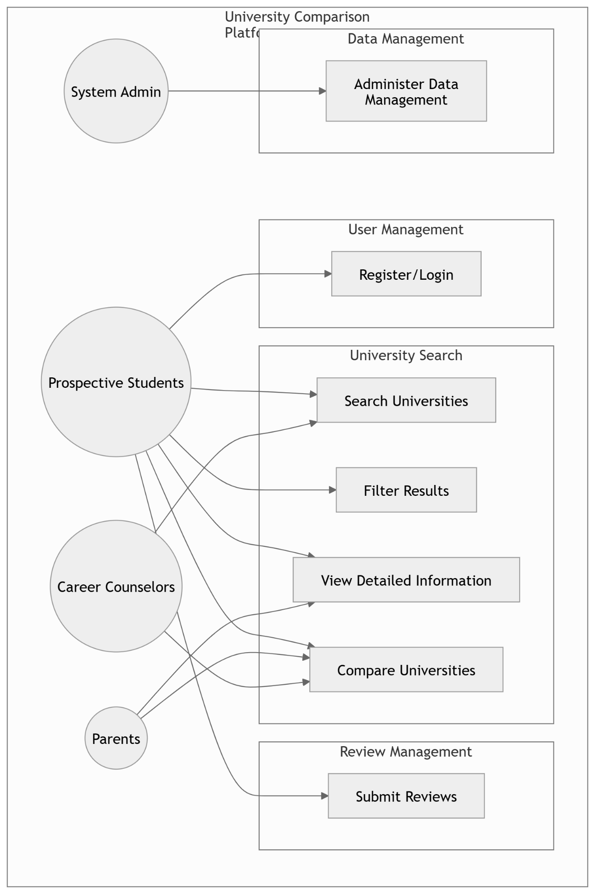

Figure 3. 1: Work Flow Diagram

*Fig 3.1* illustrates the featuring functionalities for different user types. System Admin manages data, while prospective students, career counselors, and parents can register, search, filter, compare universities, view detailed information, and submit reviews.

### 3.1.2. Class Diagram

**Classes and Relationships:**

1. **User:** Attributes include ID, name, email, password, and role (student, parent, and counselor).
2. **University:** Attributes include ID, name, location, ranking, and contact information.
3. **Department:** Linked to universities with attributes like department ID, name, and description.
4. **Program:** Linked to departments with attributes like program ID, name, duration, and fees.
5. **Feedback:** Associated with users and universities, includes rating and comment attributes.

**Relationships:**

**User to Feedback:** One-to-Many

**University to Department:** One-to-One

**Department to Program:** One-to-One

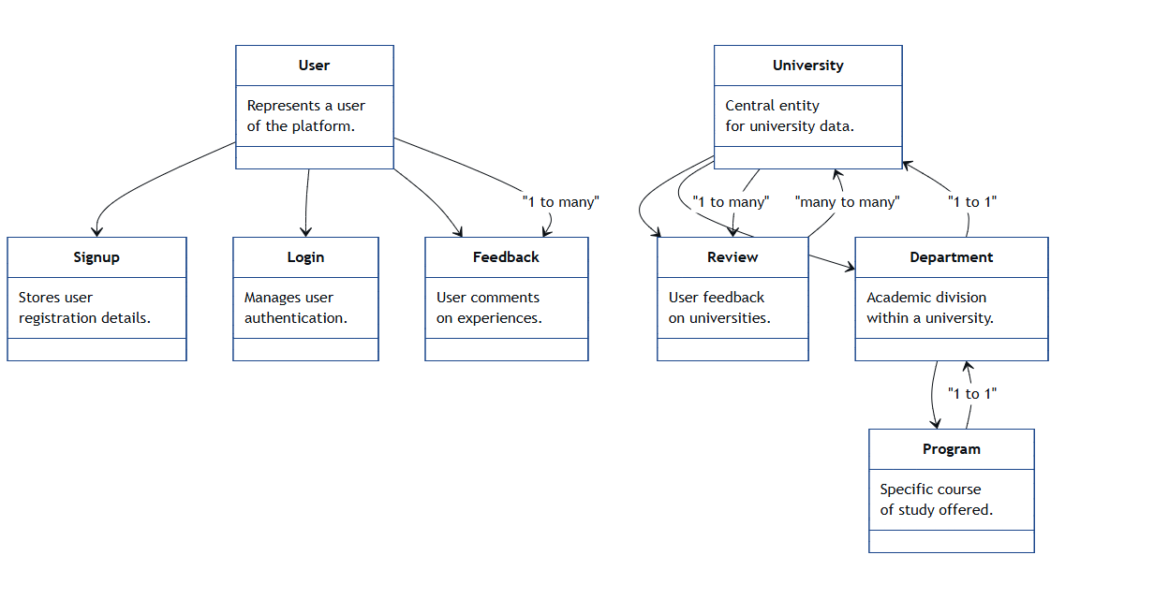

Figure 3. 2: Class Diagram

*Fig 3.2* shows that the **User** can sign up, log in, and leave feedback or reviews, while **Universities** contain departments and receive reviews from users. Each **Department** is linked to a **Program,** and relationships such as “one-to-many” and “many-to-many” define how data flows across users, universities, departments, and academic programs.

### 3.1.3. Sequence Diagram

**Example Sequence:**

User searches for universities

1. User inputs search criteria.
2. System validates input.
3. System queries database for matching universities.
4. Results are displayed.
5. User selects a university to view detailed information.

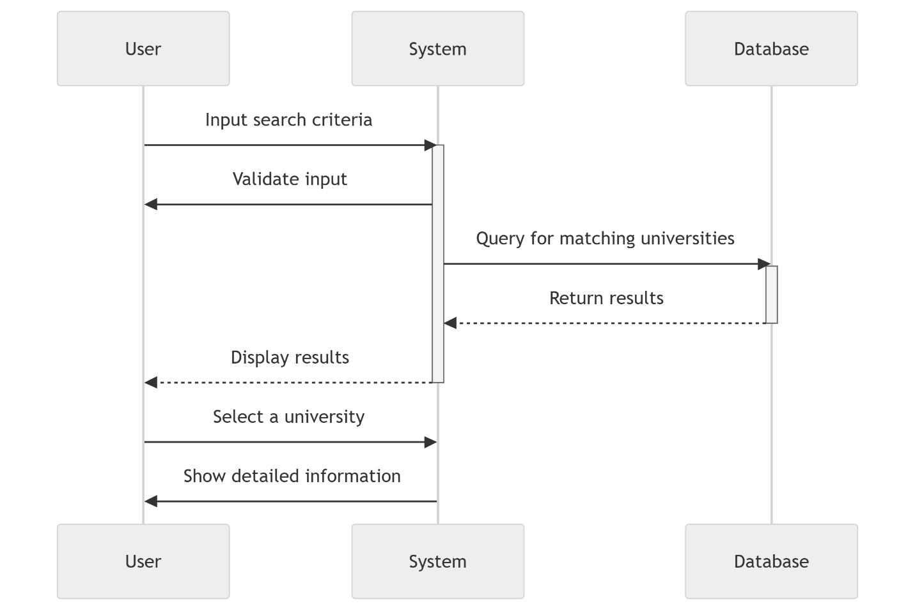

Figure 3. 3: Sequence Diagram

*Fig 3.3* shows the process of a user searching for universities. The user inputs search criteria, which the system validates before querying the database for matching universities, displaying results, and showing detailed information upon selection.

### 3.1.4. Activity Diagram

**Process for Searching Universities:**

User inputs criteria → Data is validated → Query executes → Results displayed → User selects options.

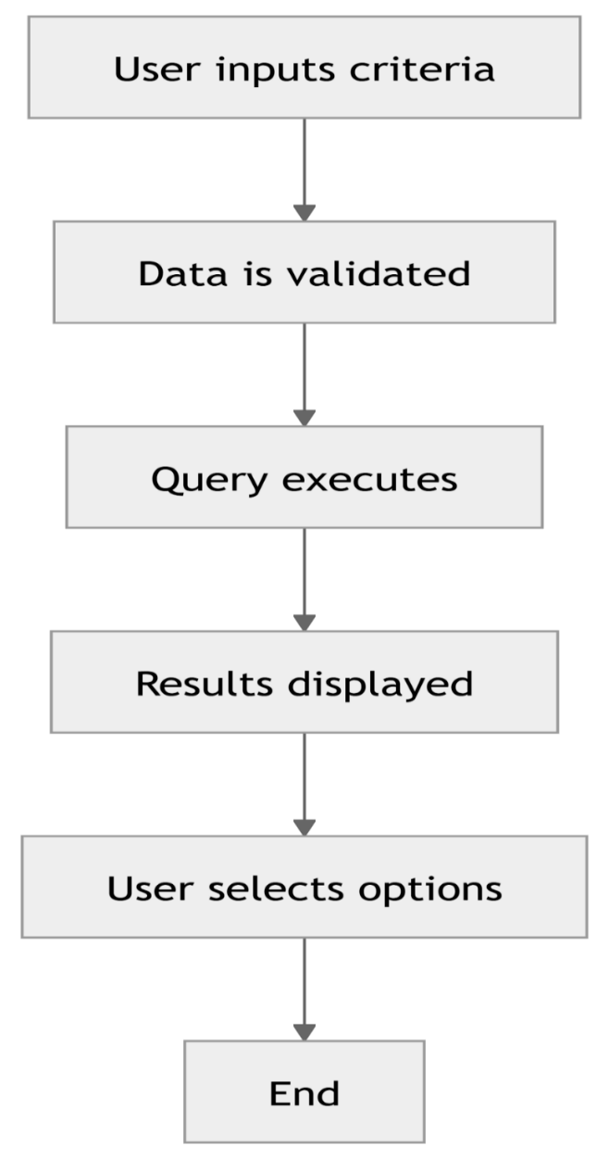

Figure 3. 4: Activity Diagram

*Fig 3.4* illustrates a process where a user provides input, the data is validated, a query is executed, results are displayed, and the user selects options, leading to the process's end. It highlights a step-by-step interaction and decision-making sequence.

## 3.2 Introduction

### 3.2.1. Purpose

The University Information Web simplifies university search and comparison by consolidating vital information into a centralized platform. The platform aims to:

1. Enable informed decisions through detailed university profiles.
2. Facilitate comparisons based on customizable parameters.
3. Support diverse users, including students, parents, and counselors.

### 3.2.2. System Overview

The platform is a responsive web-based application that provides:

1. **Comprehensive University Data:**

Admissions, programs, rankings, and campus life.

1. **Search and Comparison Features:**

Filters by location, ranking, and tuition.

1. **Interactive User Features:**

Reviews, ratings, and feedback mechanisms.

1. **Secure Access:**

Role-based authentication for different user types.

### 3.2.3. Design Map

1. **Frontend:**

Interactive UI built with HTML, CSS, and JavaScript.

1. **Backend:**

RESTful APIs built using Node.js.

1. **Database:**

MySQL for relational data storage.

1. **Cloud Services:**

AWS for hosting and scalability.

### 3.2.4. Definitions and Acronyms

1. **API:**

Application Programming Interface

1. **UI:**

User Interface

1. **DB:**

Database

1. **CRUD:**

Create, Read, Update, Delete

1. **AWS:** Amazon Web Service

## 3.3. Design Considerations

### 3.3.1. Assumptions

1. Users will access the platform through modern web browsers.
2. Institutions provide accurate and updated data periodically.
3. The platform will experience peak usage during admission seasons.

### 3.3.2. Constraints

1. Dependency on third-party data sources for accuracy.
2. Budget limitations for high-performance cloud infrastructure.
3. Compliance with privacy regulations like GDPR.

### 3.3.3. Design Methodology

The project follows ***Agile*** principles to:

1. Deliver incremental features through sprints.
2. Gather continuous user feedback for refinement.

### 3.3.4. Risks and Volatile Areas

1. **Data Volatility:**

Variability in third-party data updates.

1. **Scalability:**

Managing traffic surges during peak times.

1. **Security:**

Risks of data breaches or unauthorized access.

### 3.3.5. Risk Mitigation

1. **Data Management:**

Automate regular data validation checks.

1. **Performance Optimization:**

Use caching for frequently accessed data.

1. **Security Enhancements:**

Implement multi-factor authentication and data encryption.

## 3.4. Architecture

### 3.4.1. Overview

The architecture follows a three-tier model:

1. **Presentation Layer:**

Frontend application delivering UI to users.

1. **Application Layer:**

Backend APIs handling business logic and integrations.

1. **Data Layer:**

Centralized database for storing structured information.

### 3.4.2. Subsystem, Component

1. **User Management Subsystem:**

Handles registration, login, and role-based access.

1. **Search and Filter Subsystem:**

Implements advanced filters and sorting algorithms.

1. **Review Subsystem:**

Manages user feedback and ratings.

### 3.4.3. Strategy

1. **Micro services Architecture**:

For modular development and easy scaling.

1. **APIs**:

To ensure seamless integration with external systems.

## 3.5. Database Schema

### 3.5.1. Tables, Fields, and Relationships

**Key Tables:**

1. **Users:**

ID, name, email, password, role

1. **Universities:**

ID, name, location, ranking, tuition

1. **Departments:**

ID, university ID (foreign key), name

1. **Programs:**

ID, department ID (foreign key), name, duration, fees

1. **Reviews:**

ID, user ID (foreign key), university ID (foreign key), rating, comment

### 3.5.2. Data Migration

1. **Process:**

Extract legacy data, transform to match schema, and load into the database.

1. **Validation:**

Ensure completeness and correctness through automated scripts.

## 3.6. High-Level Design

### 3.6.1. View / Model Element

1. **View:**

ReactJS components for intuitive user interactions.

1. **Model:**

ORM-based mappings to database tables for efficient CRUD operations.

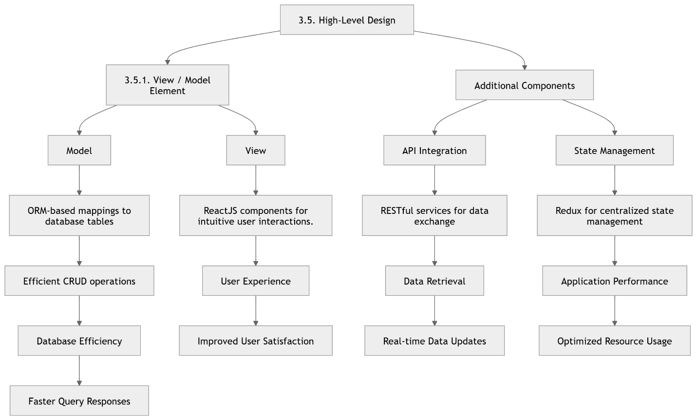

Figure 3. 5: High-Level Design

*Fig 3.5* represents a high-level design, breaking down the system into View/Model and Additional Components. It highlights ORM mappings for database efficiency, ReactJS for user experience, RESTful API for real-time updates, and Redux for optimized state management.

## 3.7. Low-Level Design

### 3.7.1. Module

1. **Authentication Module:**

Secure login/logout features using JWT.

1. **Search Module:**

Handles input validation and queries.

1. **Comparison Module:**

Manages data aggregation and display for side-by-side comparisons.

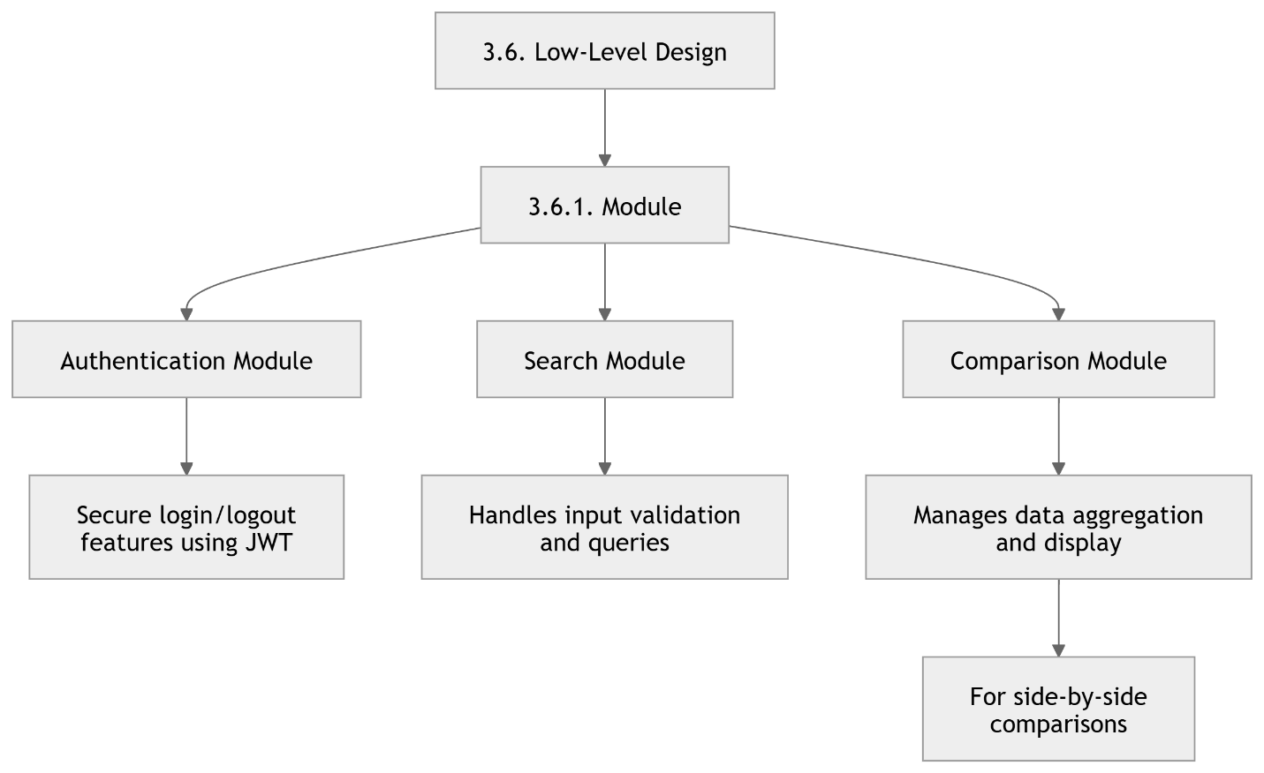

Figure 3. 6: Low-Level Design

*Fig 3.6* outlines three modules: Authentication (ensuring secure login/logout with JWT), Search (handling input validation and queries), and Comparison (managing data aggregation and side-by-side comparisons). Each module is focused on specific functionalities to enhance system reliability and usability.

## 3.8. User Interface Design

### 3.8.1. Application Controls

1. **Navbar:**

Quick navigation to sections like Search, Compare, Reviews.

1. **Forms:**

Input forms for registration, reviews, and search criteria.

1. **Interactive Widgets:**

Sliders for filters, tabs for content segmentation.

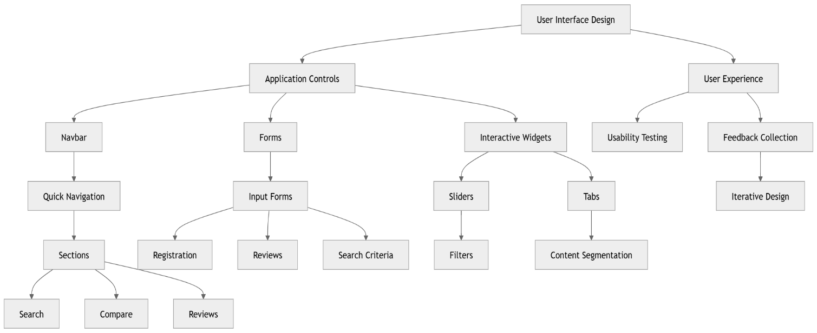

Figure 3. 7: User Interface Design

*Fig3.7* represents User Interface Design shows a mind map of different aspects of User Interface Design, including Application Controls, User Experience, Interactive Widgets, and Usability Testing.

### 3.8.2. Screenshots

1. **Home Page:**

Overview of features with search bar.

1. **Search Results:**

List view with filtering options.

1. **Comparison Page:**

Side-by-side visualization of selected universities.

## 3.9. Use Case Diagram

### 3.9.1. Actor and Use Cases

### User

Represents any visitor or registered person accessing the web portal.

### Login

Allows the user to authenticate into the system.

### View Academic Programs

Displays available academic courses offered by universities.

### Explore Campus Life

Shows information about student life, facilities, and campus environment.

### Access Admissions

Provides details about admission criteria, processes, and deadlines.

### Compare Universities

Let’s users compare multiple universities based on features like fees, programs, etc.

### View University Profiles

Opens detailed profiles for each listed university.

### Search Universities

Enables the user to search universities using filters or keywords.

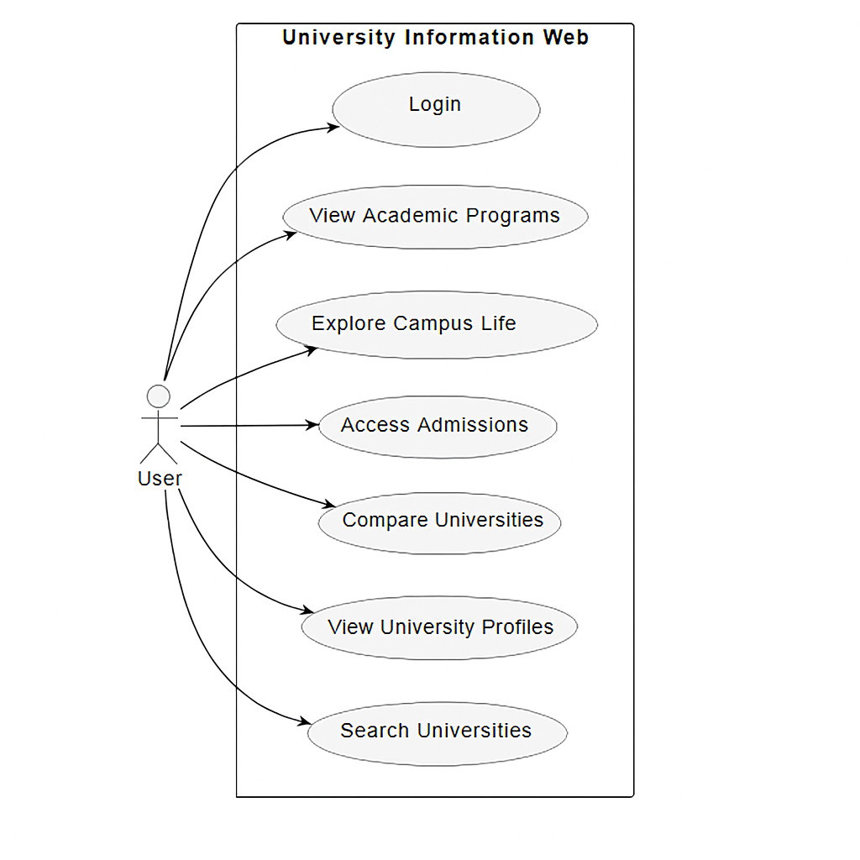

Figure 3. 8: Use Case Diagram

*Fig3.8* shows how a user interacts with the "University Information Web" system. The user can log in, view academic programs, explore campus life, access admissions, compare universities, view profiles, and search universities. Each action is represented as a use case linked to the user.

## 3.10. Architecture Diagram

### 3.10.1. Web Browser

1. **(User Interface):** Where users interact with the portal.

### 3.10.2 Web Server

1. **Web Server:** Serves static HTML, CSS, and JS files to the browser.

### 3.10.3 Application Logic

1. **Application Logic:** Handles UI, search, and routing.

### 3.10.4 University Cards

1. **University Cards:** Provide links to external university websites or internal detail pages.

### 3.10.5 Sign-In Page

1. **Sign-In Page:** For user authentication.

### 3.10.6 Database

1. **Database:** Stores user authentication data and university information.

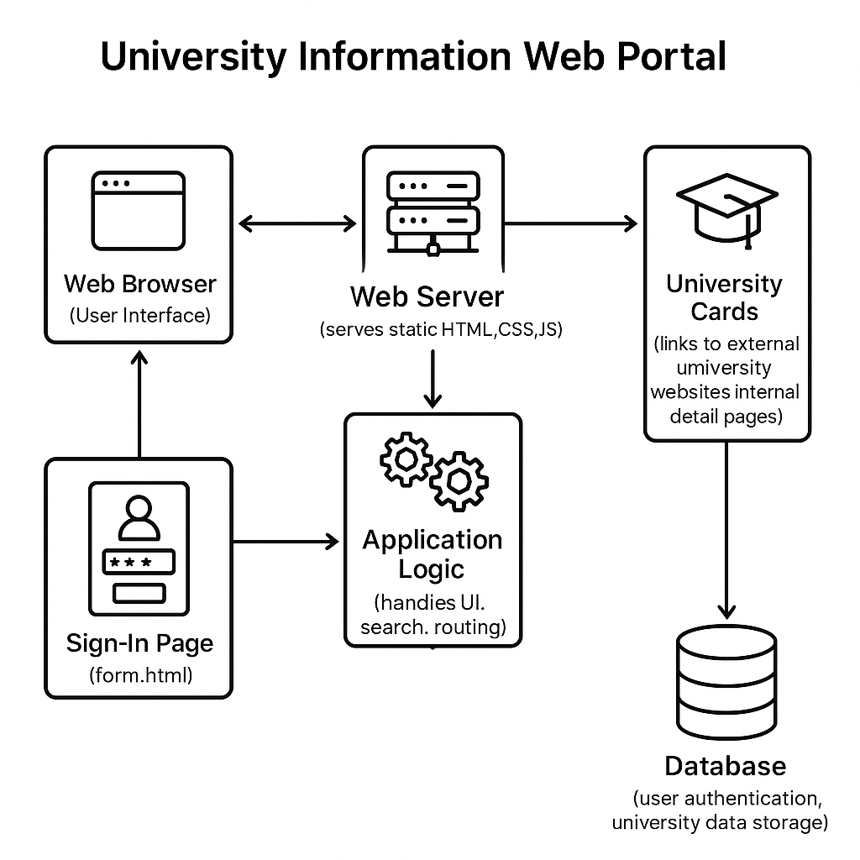

Figure 3. 9: Architecture Diagram

*Fig3.9* illustrates that the user access information through a web browser, which communicates with a web server serving static content. Application logic manages user interactions, search, and navigation, connecting users to university cards and the sign-in page. A backend database handles user authentication and stores university data, supporting secure and dynamic access.

## 3.11. Summary

The University Information Web project is a comprehensive, scalable, and user-centric platform designed to address the diverse needs of prospective students, parents, and counselors. The architecture and design ensure reliability, ease of use, and adaptability for future enhancements.

**Chapter 4 Implementation**

# Chapter 4: Implementation

## 4.1. Discussion

The discussion section highlights the rationale and key considerations driving the implementation phase.

### 4.1.1. Problem-Solving Approach

1. The University Information Web addresses the challenges of scattered and inconsistent university data by centralizing information in an intuitive platform.
2. A focus on accessibility and simplicity ensures users with varying technical expertise can navigate and utilize the platform effectively.

### 4.1.2. User-Centric Design Philosophy

1. A primary objective during implementation is to prioritize the needs of the platform’s core users—students, parents, and advisors.
2. User feedback and usability testing are integral to refining features and ensuring satisfaction.

### 4.1.3. Scalability and Flexibility

1. The platform is designed to accommodate a growing database of universities, programs, and user interactions.
2. Modular design principles are adopted to allow for the seamless addition of new features or integrations in the future.

## 4.2. Development Methodologies

This section outlines the structured approaches employed to guide the development process.

### 4.2.1. Agile Development

1. Why Agile? Agile methodologies were chosen for their adaptability and iterative nature, enabling continuous improvements based on user feedback.
2. Key Practices:
3. Dividing the project into manageable sprints to focus on incremental progress.
4. Regularly reviewing and testing each module for quality assurance.
5. Engaging stakeholders throughout the development cycle to align with their expectations.

### 4.2.2. User-Centered Design (UCD)

1. Prototyping and wire framing played a pivotal role in visualizing the platform's layout and features before full-scale development.
2. Usability tests conducted with representatives of the target audience helped identify pain points and areas for enhancement.

### 4.2.3. Data-Driven Decision-Making

1. Extensive research on university data formats, user preferences, and global education trends informed the platform's features and structure.
2. Analytics tools were integrated to monitor user behavior post-launch, providing insights for future updates.

## 4.3 Implementation Tools and Technologies

This section describes the tools, frameworks, and technologies utilized during the development process.

### 4.3.1. Programming Languages and Frameworks

1. Frontend: HTML5, CSS3, and JavaScript (React.js) for creating a responsive and interactive user interface.
2. Backend: Node.js and Express.js to manage server-side operations and ensure a smooth flow of data.

### 4.3.2. Database Management

1. MongoDB was selected for its scalability and flexibility in handling diverse university data.
2. Structured data storage ensures quick retrieval and efficient management of large datasets.

### 4.3.3. APIs and Integrations

1. RESTful APIs were implemented to connect the frontend with backend services securely.
2. Third-party integrations (e.g., Google Maps for campus locations, LinkedIn for alumni connections) enhanced the platform's functionality.

### 4.3.4. Hosting and Deployment

The platform is hosted on cloud services like AWS, ensuring high availability, scalability, and robust security measures.

### 4.3.5. Version Control

Git and GitHub were used to track changes, collaborate among team members, and maintain code integrity.

### 4.3.6. Testing Tools

1. Selenium and Jest were employed for automated testing, covering both the UI and backend functionalities.
2. Manual testing sessions ensured that user experience and performance standards were met.

## 4.4 Summary

The implementation phase is the heart of the University Information Web project, bridging the gap between conceptualization and a functional platform. By adhering to agile principles, leveraging modern technologies, and maintaining a user-focused approach, the team ensured the creation of a robust and scalable solution. This chapter has outlined the thoughtful methodologies, tools, and strategies used to deliver a platform capable of transforming how users explore and evaluate universities.

**Chapter 5 Testing**

# Chapter 5: Testing

Effective testing is a crucial phase in the software development lifecycle that ensures the system performs as expected and meets user requirements. For the *University Information Web*, thorough testing was conducted to validate functionality, usability, performance, and overall system reliability. This chapter outlines the testing techniques applied, the test cases used, the results observed, and a summary of key findings.

## 5.1 Testing Techniques Employed for This Project

To ensure the quality and robustness of the University Information Web, the following testing techniques were employed:

**Black Box Testing**

This approach was used to evaluate the system's functionality without inspecting the internal code. It focused on input/output and user interaction, ensuring that features such as login, university search, and map integration worked correctly.

**Box Testing**

Applied during unit testing to assess the logic of the code. Developers manually verified functions related to data retrieval, filters, and user authentication.

**Functional Testing**

Verified that all modules of the system (search filters, login/logout, university profile viewing, etc.) met the defined specifications and worked as intended.

**Integration Testing**

Tested the interactions between modules, such as communication between the database and the user interface, especially for fetching and displaying university data.

**Usability Testing**

Evaluated the user interface for intuitiveness, accessibility, and ease of navigation. Feedback was gathered from prospective students and educational advisors.

**Performance Testing**

Assessed the website's response time and loading speed, especially when handling multiple search queries and accessing university profiles.

## 5.2 Test Cases

*Table 5.1* representative test cases was created to cover critical functionalities of the system. Below are a few examples:

| **Test Case ID** | **Description** | **Input** | **Expected Output** | **Status** |
| --- | --- | --- | --- | --- |
| TC01 | User login with valid credentials | Username & Password | Redirect to dashboard | Pass |
| TC02 | Search university by name | "Iqra University" | Display Iqra University profile | Pass |
| TC03 | Filter universities by city | "Islamabad" | List of universities in Islamabad | Pass |
| TC04 | View detailed university profile | Click on university card | Show academic programs, admission criteria, etc. | Pass |
| TC05 | Login with invalid credentials | Wrong password | Display error message | Pass |
| TC06 | Map feature to show nearest universities | Location access granted | Display map with university markers | Pass |
| TC07 | Search with empty field | No input | Display validation error | Pass |
| TC08 | Responsive UI on mobile device | Open website on phone | Elements adjust to screen size | Pass |

Table 5.1: Test Cases

## 5.3 Test Results

All core features of the system were tested using the above techniques and test cases. The following results were observed:

1. All major functionalities performed as expected under normal usage conditions.
2. Login and authentication mechanisms correctly enforced access restrictions.
3. Search and filtering worked accurately and returned relevant data.
4. The university map feature correctly used geolocation and displayed nearby institutions.
5. UI/UX feedback from users indicated a positive experience with intuitive navigation and fast response times.
6. The platform was compatible with common web browsers (Chrome, Firefox, and Edge) and mobile devices.
7. Minor bugs were identified and resolved, such as improper error messages and UI misalignment on certain screens.

## 5.4 Summary

The testing phase confirmed that the **University Information Web** is stable, user-friendly, and performs reliably under expected conditions. By using a combination of black box, white box, and usability testing methods, the platform was validated against its functional requirements. The test cases executed covered both normal and edge scenarios, ensuring the robustness of the system. Overall, the system is ready for deployment and real-world usage, offering users a seamless experience in accessing comprehensive university information from a centralized platform.

**Chapter 6 Conclusion and Future Work**

# Chapter 6: Conclusion and Future Work

## 6.1 Conclusion

The launch of the University Information Web is a transformative step in how prospective students and their families discover, compare, and evaluate higher education institutions. In a world where information is often scattered and unreliable, this innovative platform offers a centralized solution. By consolidating essential details, such as admission criteria, academic programs, campus facilities, and location-based filters, it empowers users to make informed educational choices. The project's primary goal was to streamline the outdated university search process, which traditionally relies on brochures, official websites, and third-party reviews. This platform eliminates the need to consult multiple sources by providing standardized, up-to-date university profiles in one easy-to-navigate location. With a user-friendly interface and dynamic features—such as search by name, location filters, detailed profiles, and integrated mapping—it ensures accessibility across devices. Rigorous testing phases have verified the platform's reliability, ensuring accurate information, quick response times, and strong data security. Overall, the University Information Web stands as a vital resource for students, parents, and advisors, guiding them through the complex landscape of higher education planning.

## 6.2 Future Work

While the current implementation of the University Information Web provides a solid foundation, there are numerous opportunities for enhancement and expansion in future iterations. These improvements aim to increase functionality, usability, and reach, ensuring the platform remains current and competitive in a rapidly evolving digital ecosystem.

### 6.2.1 Real-Time Data Integration

A major improvement would be the introduction of automated data synchronization with official university portals through APIs. This would enable real-time updates for:

1. Admission deadlines
2. Course offerings
3. Tuition fee changes
4. Scholarship announcements

This ensures the data remains accurate and reflects current academic cycles, eliminating any risk of users accessing outdated information.

### 6.2.2 User Registration and Personalization

Adding user accounts would allow visitors to register, log in, and personalize their experience. Personalized dashboards could include:

1. Shortlisted universities
2. Customized filters (e.g., preferred cities, programs)
3. Notifications on application deadlines
4. Recently viewed institutions
5. This level of interactivity will enhance user engagement and retention.

### 6.2.3 Global University Inclusion

The current database may focus primarily on a specific region or country. Future development should aim to incorporate universities from around the world to cater to international students. Features such as:

1. Region-specific filters
2. Currency conversion for tuition fees
3. Multilingual support would make the platform accessible to a global audience.

### 6.2.4 Application Process Integration

To extend its usefulness, the platform could integrate links or embedded portals for university applications. This could allow users to:

1. Apply directly through the platform
2. Upload documents
3. Track application progress
4. This feature would turn the platform from an information hub into a comprehensive educational solution.

### 6.2.5 Community Features: Reviews and Forums

User-generated content in the form of reviews, ratings, and discussion forums would bring a social dimension to the platform. Prospective students could benefit from:

1. Real experiences shared by alumni and current students
2. Discussions around campus life, accommodation, and cultural environment
3. Peer recommendations and warnings

### 6.2.6 AI-Based Recommendation Engine

Leveraging artificial intelligence and machine learning would make the platform smarter and more adaptive. Based on user input such as grades, interests, preferred location, and budget, the system could suggest the most suitable universities. A recommendation engine would also enhance user satisfaction by offering curated and relevant results.

### 6.2.7 Mobile Application Development

Although the current platform is responsive, dedicated mobile applications would offer a more fluid and performance-optimized experience. Additional mobile features could include:

1. Offline access to saved data
2. Push notifications
3. Voice search capability
4. Developing apps for Android and iOS would further broaden the platform’s accessibility.

### 6.2.8 Administrative Dashboard for Universities

Creating a backend interface for university representatives would allow them to:

1. Update their profiles
2. Post news, events, or scholarship programs
3. Respond to user queries
4. This would ensure the system remains accurate and increases institutional involvement.

## 6.3 Final Thoughts

The University Information Web project successfully achieves its mission of simplifying and enhancing the university selection process through a centralized digital solution. By compiling a wide range of verified and standardized university data, the platform resolves one of the most common pain points in the academic journey—lack of accessible, trustworthy information. However, the potential for growth and improvement is vast. Future versions can leverage modern technologies such as AI, automation, and mobile computing to further elevate user experience and expand global outreach. By incorporating user feedback and adapting to changing educational trends, the University Information Web can evolve into a holistic ecosystem that not only informs but also guides users throughout their higher education journey. The project, as it stands today, is a solid starting point—an essential step toward redefining how students and parents approach one of the most important decisions of their lives.

# References:

1. **Iqra University**  
   [https://iqra.edu.pk](https://iqra.edu.pk/)
2. **FAST ( FAST National University of Computer and Emerging Sciences)**  
   [https://nu.edu.pk](https://nu.edu.pk/)
3. **NUML (National University of Modern Languages)**  
   [https://numl.edu.pk](https://numl.edu.pk/)
4. **NUST (National University of Sciences and Technology)**  
   [https://nust.edu.pk](https://nust.edu.pk/)

#### **HTML**

1. **MDN Web Docs:** [HTML Reference](https://developer.mozilla.org/en-US/docs/Web/HTML)
2. **W3Schools:** [HTML Tutorial](https://www.w3schools.com/html/html_intro.asp)

#### **CSS**

1. **MDN Web Docs:** [CSS Reference](https://developer.mozilla.org/en-US/docs/Web/CSS)
2. **W3Schools:** [CSS Basics](https://www.w3schools.com/css/css_intro.asp)

#### **JavaScript**

1. **MDN Web Docs:** [JavaScript Guide](https://developer.mozilla.org/en-US/docs/Web/JavaScript/Guide)
2. **W3Schools:** [JavaScript Introduction](https://www.w3schools.com/js/js_intro.asp)

#### **Responsive Design**

1. **MDN Web Docs:** [Using Media Queries](https://developer.mozilla.org/en-US/docs/Web/CSS/Media_Queries/Using_media_queries)
2. **CSS-Tricks:** [A Complete Guide to CSS Media Queries](https://css-tricks.com/a-complete-guide-to-css-media-queries/)